IDH35
Integrated Pulse-Type Open-Loop Stepper Driver

User Manual V1.0.0

Shenzhen GRMOT Technology Co., Ltd.

Table of contents
1. Product Introduction - 1 -
1.1 Product Overview - 1 -
1.2 Product Features - 1 -
1.3 Application Areas - 1 -
1.4 Naming Rules - 2 -
2. Electrical, mechanical and environmental indicators - 3 -
2.1 Mechanical Installation Drawings - 3 -
2.2 Installation Precautions - 3 -
2.3 Electrical Specifications - 3 -
2.4 Usage Environment and Parameters - 4 -
3. Driver Interface and Wiring Introduction - 4 -
3.1 Interface Diagram - 4 -
3.2 Interface Description - 4 -
3.2.1 Power Input Interface - 4 -
3.2.2 Control Signal Interface - 5 -
3.2.3 Output Signal Interface - 5 -
3.2.4 RS485 Interface - 5 -
3.2.5 Programming and Debugging Interface - 6 -
3.2.6 Status Indication - 6 -
3.3 Input Control Signals - 7 -
3.3.1 Input control signal interface circuit - 7 -
3.3.2 Control Signal Timing Diagram - 7 -
3.3.3 Control Signal Mode Settings - 8 -
3.4 Output control signal - 8 -
3.4.1 Used for alarm and position output. - 8 -
3.4.2 Used as a control brake motor - 9 -
3.5 Wiring Requirements - 11 -
4. Power supply selection - 11 -
5. Indicator lights and alarm indicators - 12 -
6. Compatible motor parameters and selection - 13 -
6.1 Schematic diagram of motor appearance - 13 -
6.2 Motor Technical Parameters - 14 -
6.3 Motor Shaft Parameters - 14 -
6.4 Wiring Definition - 14 -
7. Warranty and after-sales service - 14 -
7.1 Warranty - 14 -
7.1.1 Free Warranty Status - 14 -
7.1.2 Cases not covered by warranty - 14 -
7.2 Exchange - 15 -
7.2.1 Product replacement due to malfunction - 15 -
7.2.2 Replacement for non-product malfunctions - 16 -
7.3 Returns - 16 -
7.4 After-sales service - 17 -
8. Version Revision History - 17 -

Product Introduction

1.1 Product Overview
IDH35 Integrated Pulse-Type Open-Loop Stepper DriverThis is a new type of integrated motor driver recently launched by Gree IoT Technology Co., Ltd. It adopts the latest dedicated motor control digital signal processor to improve the overall performance of the motor, reduce the heat generation of the motor and reduce the vibration of the motor. The motor and driver are integrated into one unit, making the installation more compact and reducing external interference.
IDH35It features serial port debugging functionality and uses a MINI USB interface for communication. Users can set various parameters such as microstepping, current, and operating mode through PC-based debugging software, greatly enriching the product's practical functions and meeting the needs of most applications.

1.2 Product Features
●Integrated motor and drive, saving on wiring labor.
● Compact size, easy to install
● New generation 32-bit DSP technology, offering excellent stability, strong compatibility, and high cost-effectiveness.
● Optically isolated differential signal input
● Built-in micro-stepping ensures excellent low-speed stability
● Pulse response frequency up to 200kHz (higher frequencies can be achieved)
●Subdivision setting range: 200-60000 (arbitrary subdivision can be set via host computer)
●Precision current control significantly reduces motor heat generation.
●Low vibration and low noise
●Features alarm protection functions for overvoltage, undervoltage, and phase loss.
●Input voltage range:DC12V~40V
●The default effective current is 1.0A (any current value can also be set via the host computer).

1.3 Application Areas
Suitable for various small and medium-sized automated equipment and instruments, such as medical equipment, testing equipment, marking machines, plotters, etc. Meets customer requirements for low noise, low heat generation, convenient wiring, and stronger anti-interference capabilities.

1.4 Naming Rules
The naming conventions for driver models are as follows:
I DH 35M---
① ② ③ ④ ⑤ ⑥ ⑦ ⑧ 9

Serial Number | meaning
① | 2-phase/3-phase distinction; Open: 2-phase drive;
② | General term for product series; I: Integrated drive;
③ | Product series number; DH:pulseopenring;
④ | Matching motor base; 35: Primary match35The motor in the base;
⑤ | Integrated bus series with open and closed loop distinctions;
⑥ | Does it include a motor? M: Integrated with motor;
⑦ | The motor body is long;
⑧ | Special function codes;
9 | Design change code;

Electrical, mechanical and environmental indicators

2.1 Mechanical Installation Drawings
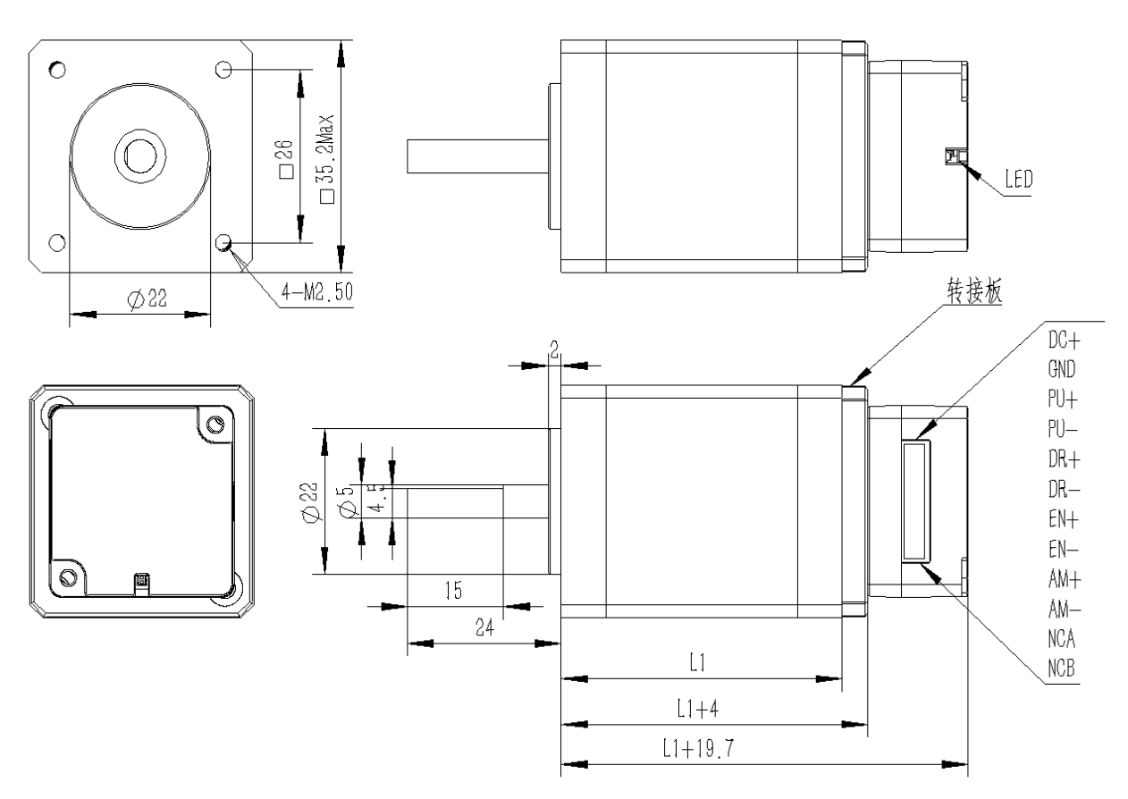
Figure 2.1 Installation dimensions (unit: mm)

2.2 Installation Precautions
- When installing an integrated stepper driver, do not strike the rear cover of the motor to avoid affecting its performance. When designing the installation dimensions, the size of the wiring terminals and the wiring should be taken into account.
- To ensure good heat dissipation, a large installation gap must be reserved during actual installation. If multiple integrated drives are installed side by side, fans can be installed to create strong air convection on the surface of the integrated drive, which will help dissipate heat and ensure that the drive operates within a reliable operating temperature range.

2.3 Electrical Specifications
illustrate | IDH35
illustrate | Minimum value | Typical value | Maximum value | unit
Input power supply voltage | 12 | twenty four | 40 | VDC
Control signal input current | 7 | 10 | 16 | mA
Step pulse frequency | 0 | - | 200 | KHz
Insulation resistance | 50 |  |  | MΩ

2.4 Usage Environment and Parameters
Cooling method |  | Natural cooling, fan cooling
Usage Environment | occasion | Do not place near other heat-generating equipment. Avoid dust, oil mist, corrosive gases, high humidity, and areas with strong vibrations. Keep out of reach of flammable gases and conductive dust.
Usage Environment | temperature | 0-50℃
Usage Environment | humidity | 40-90%RH
Usage Environment | vibration | 10~55Hz/0.15mm
Storage temperature |  | -20℃~65℃

Driver Interface and Wiring Introduction

3.1 Interface Diagram
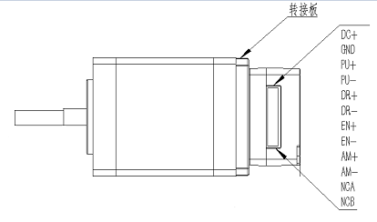
Figure 3.1IDH35Interface diagram

3.2 Interface Description
IDH35 Integrated Pulse-Type Open-Loop Stepper DriverThe power interface, signal control interface, and output signal interface use JST 1.25-12P pin headers. See the following sections for detailed interface definitions.

3.2.1 Power Input Interface
name |  | illustrate | Function
VDC | DC+ | Power interface | Power input  DC12V~40V
VDC | GND | Power interface | Power input  DC12V~40V

3.2.2 Control Signal Interface
name | Function
PU+ | Pulse control signal: Can be driven by +5V-+24V, rising edge is valid, the motor moves one microstep each time the pulse changes from low to high. For reliable response to the pulse signal, the pulse width should be greater than 2.5μs.
PU-
DR+ | Direction control signal: Can be driven by +5V-+24V, high/low level signal. To ensure reliable motor commutation, the direction signal should be established at least 50μs before the pulse signal.
DR-
EN+ | Enable control signal: Can be driven by +5V to +24V, high/low level signal. Used to enable or disable motor operation. When EN+ is connected to +5V and EN- is connected to a low level, the driver will cut off the current to each phase of the motor, putting the motor in a free state. At this time, the step pulse will not be responded to. When this function is not needed, the enable signal terminal can be left floating. In addition, the EN terminal can also be used to clear the over-tolerance alarm signal.
EN-

3.2.3 Output Signal Interface
The output signal interface is used by default as an alarm output function. The output signal is valid when overvoltage, undervoltage, or phase loss alarms occur. In addition, the output interface can also be configured for position output or brake control output functions via PC software. Users can make corresponding settings according to their actual usage.
name | Function
AM+ | Alarm signal output: The alarm signal output is valid when overvoltage, undervoltage, or phase loss alarms occur;  Normally open or normally closed connections are described in section 3.4;  Maximum drive current 50mA.
AM-

3.2.4 RS485 Interface
IDH35 Integrated Pulse-Type Open-Loop Stepper DriverThe interface uses a JST1.25-12P pin header, where pins 11 and 12 are defined for 485 communication.

name | Function
NCA | RS485 communication interface A end; reserved port, this is a pulse type driver and does not support RS485 communication, so it does not need to be connected;
NCB | RS485 communication interface B; reserved port, this is a pulse type driver and does not support RS485 communication, so it does not need to be connected.

3.2.5 Programming and Debugging Interface
IDH35The driver's serial communication interface uses a MINI USB interface. It can be connected to a PC via a USB to TTL serial converter using the dedicated debugging cable provided by our company. Hot-plugging is strictly prohibited! On the PC, customers can set the required parameters, such as current, microstepping, and operating mode. For details, please refer to the host computer software interface.
Terminal number | symbol | name | illustrate
1 | NC | - | For internal use
2 | NC | - | For internal use
3 | GND | Serial communication ground | 0V
4 | NC | - | For internal use
5 | NC | - | For internal use
6 | NC | - | For internal use
7 | RXD | Serial port receiver
8 | TXD | Serial port transmitter
▶Note:IDH35The debugging cable that connects to the PC is a dedicated cable (provided depending on the user's needs). Please confirm before use to avoid damage.

3.2.6 Status Indication
IDH35 Integrated Pulse-Type Open-Loop Stepper DriverThe indicator light is a recessed surface-mount LED, and its basic definition is shown in the table below.
name | Function | illustrate
Green LED | Power indicator, save parameter function indicator, factory reset function indicator, DIP switch status switching indicator.  Alarm indicator light | When the power is on normally, the green light is always on and the red light is off. When parameters are saved, factory settings are restored, DIP switch status is changed, or the device malfunctions, the red and green lights will flash alternately as an alarm. See Chapter 5 for the flashing pattern.
Red LED

3.3 Input Control Signals

3.3.1 Input control signal interface circuit
IDH35The driver control signal terminal adopts a differential interface circuit, which is compatible with differential signals, single-ended common cathode and common anode interfaces, etc. It has a built-in high-speed optocoupler and strong anti-interference ability in harsh environments. The interface circuit diagram is shown in Figure 3.2.
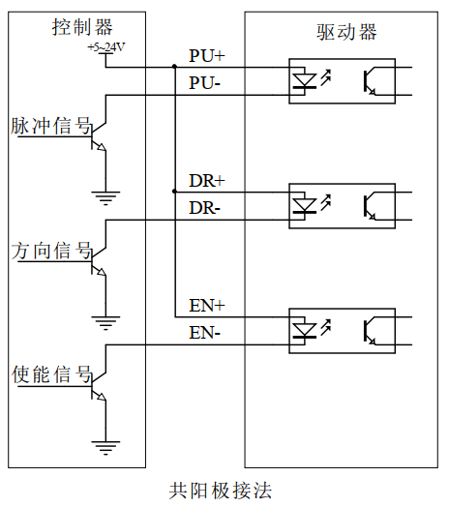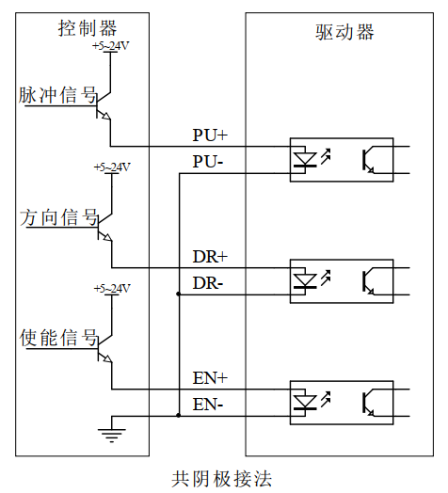
Figure 3.2 Input Interface Circuit
▶Note:IDH35It is a 5V-24V universal driver, so no series resistor is needed at the signal control end!

3.3.2 Control Signal Timing Diagram
To avoid malfunctions and deviations, PU, ​​DR, and EN should meet certain requirements, as shown in the figure below:
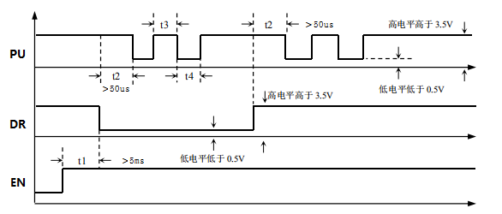
Figure 3.3 Control signal timing diagram
Note:
- t1: EN (enable signal) should be high at least 5ms before DR. Generally, it is recommended to leave EN+ and EN- floating.
- t2: DR determines its state as high or low at least 50 μs before the falling edge of PU.
- t3: The pulse width is at least 2.5 μs.
- t4: Low-level width is not less than 2.5μs.

3.3.3 Control Signal Mode Settings
Pulse trigger edge selection: The rising edge or falling edge of the pulse can be selected as the trigger edge via PC software.

3.4 Output control signal
After the driver is powered on normally, the initial default valid state of the output interface is normally open output.Users can also configure the valid state of the output interface through the main station, initially defaulting to normally closed output.

3.4.1 Used for alarm and position output.
The diagram below shows the wiring diagram when the output signal port is used as an alarm output function (the wiring method is the same when it is used as a position output):
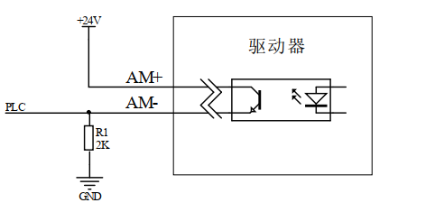
Figure 3.4 Schematic diagram of normally closed output interface
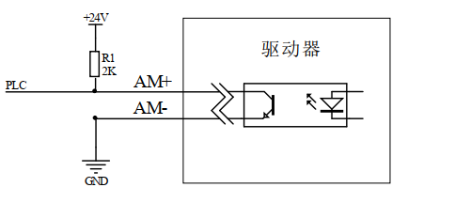
Figure 3.5 Schematic diagram of normally open output interface

3.4.2 Used as a control brake motor
IDH35 Integrated Pulse-Type Open-Loop Stepper DriverThe output port includes control functions for the brake motor brake. Users only need to set the output port function to 'brake control signal' through the PC-based host computer debugging software to control the brake motor brake via the AM+ and AM- ports.
The following diagram shows the wiring schematic of the brake motor holding brake. Relevant parameters are described in the table below:
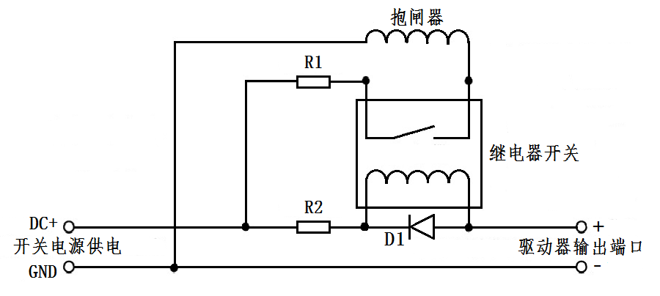
Figure 3.6 Wiring diagram of brake motor holding brake
name | logo | illustrate
Switching power supply | DC+ | Connect to +24 or +5V power supply
Switching power supply | GND | grounding terminal
Driver output port | AM+ | Output port + terminal
Driver output port | AM- | Output port - terminal
Protective resistor | R1 | If the brake is powered by DC24V, then R1 can be smaller or not connected at all; if the brake is powered by DC5V, then R1 should be larger.
Protective resistor | R2 | R2 can be connected to a 1~2K resistor to limit the current and prevent damage to the optocoupler components inside the driver;  You can refer to the relay specification sheet to determine whether it needs to be connected.
freewheeling diode | D1 | To protect the internal components of the driver from damage by induced voltage; refer to the relay specification sheet to determine whether connection is necessary.
Brake |  | The control mechanism for the brake motor is generally in the released state after the power is turned on, allowing the motor to run freely. Before use, the power supply voltage must be confirmed to avoid overvoltage damaging the brake.

3.5 Wiring Requirements
- To prevent interference with the driver, it is recommended to use shielded cables for control signals, with the shield short-circuited to ground. Unless otherwise specified, the shield of the control signal cable should be grounded at one end: the host computer end of the shield should be grounded, and the driver end should be left floating. Grounding is only allowed at the same point within the same machine. If it is not a real ground wire, severe interference may occur; in this case, the shield should not be connected.
- Pulse and direction signal lines should not be bundled together with motor lines; they should ideally be separated by at least 10cm. Otherwise, motor noise can easily interfere with the pulse and direction signals, causing inaccurate motor positioning, system instability, and other malfunctions.
- If a power supply powers multiple drivers, they should be connected in parallel at the power supply point. A chain-like connection, where the power supply goes to one driver first and then to the next, is not allowed.
- It is strictly forbidden to plug or unplug the high-voltage terminals of the driver while it is powered on. Even when the motor is stopped, a large current still flows through the coil. Plug or unplug the terminals while they are powered on, which will cause a huge instantaneous induced electromotive force and burn out the driver.
- It is strictly forbidden to tin the wire ends before connecting them to the terminals, otherwise the terminals may overheat and be damaged due to increased contact resistance.
- The wire ends must not be exposed outside the terminals to prevent accidental short circuits that could damage the driver.

Power supply selection
It can operate normally as long as the power supply voltage is within the specified range.IDH35The driver is best powered by a regulated DC switching power supply, and the output current range of the switching power supply should be set to its maximum. An unregulated DC power supply can also be used, but care must be taken to ensure that the peak voltage ripple after rectification does not exceed its specified maximum voltage. It is recommended that users use a DC voltage lower than the maximum voltage to avoid mains fluctuations exceeding the driver's operating voltage range.
▶Note:
- When wiring, be careful to ensure that the positive and negative terminals of the power supply are not reversed;
- When wiring, pay attention to the position of the power interface and do not connect it to the motor port. After connecting, it is best to double-check that the connection is correct.
- It is best to use a regulated DC switching power supply;
- When using an unregulated DC power supply, the power supply current output capability should be greater than 60% of the driver's set current.
- When using a regulated DC switching power supply, the output current of the power supply should be greater than or equal to the operating current of the driver.
- To reduce costs, two or three drivers can share a single power supply, but the power supply should be sufficiently powerful.

Indicator lights and alarm indicators
IDH35 Integrated Pulse-Type Open-Loop Stepper DriverThere is a green LED and a red LED. One can be used as a power indicator, and the other can be used as a fault indicator, a DIP switch status indicator, and a parameter save or restore indicator. The specific relationship is shown in Table 6.1 below:
When the driver is powered on, the green LED is constantly lit; when the driver is powered off, the green LED is off.
When the driver malfunctions, the red and green LEDs flash alternately in a cycle, with different flashing patterns indicating different fault information. When the fault is resolved by the user, the green LED remains constantly lit, and the red LED turns off.
When saving/restoring parameters, the red and green lights flash alternately in a cycle. When saving/restoring parameters is complete, the green LED stays on and the red LED turns off.
Table 6.1 LED Status Indicators
LED blink count |  | Phenomenon | illustrate
Green LED | Red LED | After the green light finishes flashing, the red light flashes.
0 | - | Green light stays on, red light stays off | Driver enable
1 | - | Green light flashing, red light off | Received pulse signal
2 | 1 |  | Received pulse in disabled state
1 | 4 |  | Overvoltage alarm
2 | 4 |  | Undervoltage alarm
1 | 6 |  | AB phase loss alarm
2 | 6 |  | Only phase A loss alarm
3 | 6 |  | Only phase B is missing alarm
1 | 2 |  | In the process of restoring parameters
2 | 2 |  | In the process of saving parameters

Compatible motor parameters and selection

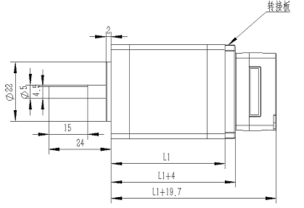
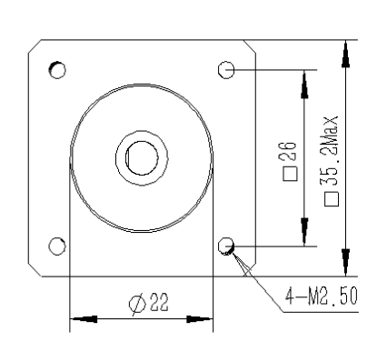
6.1 Schematic diagram of motor appearance

Figure 6.1IDH35Schematic diagram of the series all-in-one machine

6.2 Motor Technical Parameters
model | Keep  Torque (mN.M) | Phase current (A) | resistance  (Ω) | inductance  (MH) | Rotation  Inertia (g.cm2) | motor  Length L1  (mm) | Adapter board  (mm) | Tail cover  length  (mm) | weight  (Kg) | Line count
IDH35M-36 | 220 | 1.5 | 1.00 | 1.0 | 31 | 36Max. | 4 | 150.7 | 0.21 | 4
IDH35M-56 | 400 | 1.5 | 1.40 | 1.5 | 62 | 56Max. | 4 | 150.7 | 0.35 | 4

6.3 Motor Shaft Parameters
model | Shaft diameter (mm) | Shaft extension (mm) | Flat position(mm) | Boss (mm)
IDH35M-36 | 5.0 | 24 | 4.5*15 | 2*22
IDH35M-56 | 5.0 | 24 | 4.5*15 | 2*22

6.4 Wiring Definition
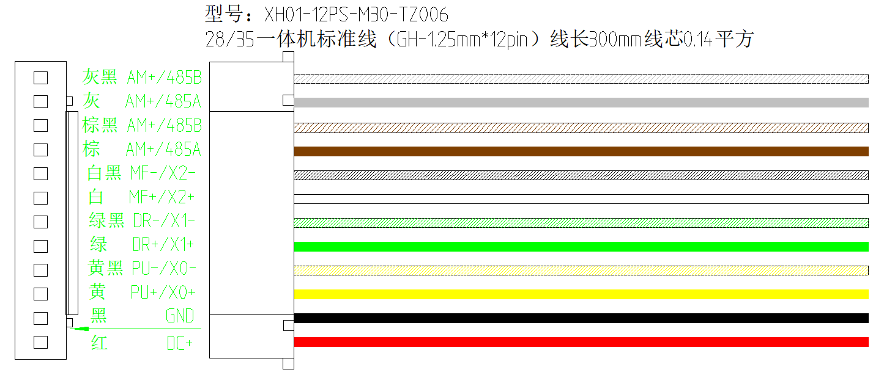
Figure 6.2IDH35Series wiring diagram

Warranty and after-sales service

7.1 Warranty

7.1.1 Free Warranty Status
Our company solemnly promises that all products purchased from us will be provided with one year of free repair service if they are damaged due to their own defects during use. The round-trip shipping costs will be shared equally by both parties.

7.1.2 Cases not covered by warranty
- The driver was damaged due to incorrect wiring by the customer.
- Exceeding the rated operating voltage can damage the driver.
- Connecting a DC-powered drive to an AC power source can damage the driver.
- The driver was damaged because the customer's site environment was extremely harsh, such as humid, extremely cold, or extremely hot, and the customer did not inform the company in advance.
- The customer disassembled the drive casing without authorization, or there were signs that the serial number had been torn off.
- The casing was visibly damaged or impacted 15 days after the customer confirmed receipt, resulting in damage to the driver.
- Unavoidable natural disasters, such as fires, earthquakes, tsunamis, typhoons, etc.;
In the above situations, our company will charge a certain repair cost fee after assessing the interests of all parties. In all other situations, repairs will be provided free of charge indefinitely.

7.2 Exchange

7.2.1 Product replacement due to malfunction
For any malfunctions in the new product itself, our company offers a three-month free replacement service.
Once our technical support staff confirms the problem is with the product itself, please send the product back to our company to avoid time and postage losses during the round trip. Customers must first send the faulty product back via express delivery or logistics. Upon receiving the product, our company will send a replacement to the customer as soon as possible.
Notice:All our products undergo rigorous testing and aging before leaving the warehouse, so malfunctions of new products are extremely rare. Please read the instruction manual carefully or consult our technical support personnel before operation, or have our technical support personnel remotely assist customers in operation.
- Please note the following points when exchanging goods:
- Please ensure the packaging is intact when returning the item to avoid damage during shipping;
- When exchanging goods, please ensure that all accessories are complete;
- Each driver should be individually packaged in its original outer box to avoid secondary damage to the product during transportation;
- If the drive is returned and tested, it is confirmed that the problem is not a product malfunction, but rather due to the customer's own operational negligence, leading them to mistakenly believe the drive was faulty. In such cases, the company will not bear the shipping costs. (Customer operational negligence includes: incorrect wiring leading to drive damage, faulty wiring leading to the mistaken belief that the drive is damaged, operational errors causing the drive to malfunction, etc.)

7.2.2 Replacement for non-product malfunctions
If a customer is dissatisfied with the appearance or function of the received product and wishes to replace it with a superior driver, they can apply for an exchange within one week of receiving the product. After verification, the product will be returned to the company. The company will replace the product with another one, provided the returned product is undamaged, all accessories are complete, and the packaging is in good condition. If there is a price difference in the replacement product, the customer will be responsible for the difference.
Note: Replaced products will no longer be eligible for non-product failure exchange services. All round-trip shipping costs and other expenses incurred for non-product failure exchange services will be borne by the customer!

7.3 Returns
Our company offers a 7-day return policy for products with quality issues. If you discover any quality problems with the product within 7 days of receiving it (based on the actual date of receipt by the customer), please contact our sales representative or technical support personnel in a timely manner. After our technical support personnel confirm that the product has quality issues, the customer should send the original complete product, its inner and outer packaging, accessories, and delivery note back to our company via express delivery or logistics.
If, after our company has inspected and confirmed that there are no errors, the customer still insists on returning the goods, the customer shall bear all round-trip shipping costs and all other expenses incurred as a result.
- Please note the following points when returning goods:
(1) Please contact the relevant department of our company before proceeding with the refund process;
(2) The product must be brand new and in its original packaging. Please send it back to our company by express delivery or logistics.
(3) We will not accept complaints about product damage, missing accessories, or other issues caused by the customer.

7.4 After-sales service
If you require after-sales service support while using this product, please contact our company immediately.
Nationwide toll-free service hotline: 0755-23206995;
Technical support hotline: 18576758897 (Mr. Xie), 17666115681 (Mr. Tuo);
Service hours: Monday to Friday, 8:30-17:30 (excluding national statutory holidays).

Version Revision History
Version number | illustrate | Modify deadline | Prepared by/Reviewed by
V1.0.0 | Initial version; | 2024.06.28 | TCJ/XH

